Histological and Immunohistochemical Study of Tramadol Induced Testicular Toxicity and Protective Effects of Resveratrol
in Adult Male Albino Rats

ABSTRACT
Background: Tramadol is a centrally acting analgesic drug. Chronic intake of Tramadol has negative impacts on testis. A polyphenol compounds such as Resveratrol which found in certain plants that has antioxidant and anti-inflammatory properties.
Aim of the work: The target of this study to investigate the protective effects of Resveratrol on the testis of adult male albino rats against testicular toxicity induced by Tramadol.
Materials and methods: Four experimental groups were served in this study. Each one included10 adult male albino rats as follows: Group I (control group): received 0.1 ml of physiological saline solution. Group II: received Resveratrol 20 mg/kg/day orally for 4 weeks. Group III: (Tramadol-treated group): received Tramadol 50 mg/kg/day orally for 4 weeks. GroupIV: received Tramadol 50 mg/kg body weight daily orally followed by Resveratrol 20 mg/kg body weight daily by intragastric gavage for 4 week. Serum levels of FSH, LH and testosterone have been estimated. Testicular specimens were processed for light microscopic examination and immunohistochemical studies and examined histologically. The data were collected from the experiment, recorded and analyzed using IBM SPSS Statistics software.
Results: Tramadol-treated group showed severe distortion of the testicular structure in which many seminiferous tubules were degenerated with distorting their normal histological structure in addition, congested blood vessels in the interstitium can be observed. Meanwhile, sections of testes of group IV (Tramadol–Resveratrol treated group) showed nearly normal histology. Positive immune-reactivity for PCNA in the control, Resveratrol treated and Tramadol - Resveratrol treated groups while, Tramadol- treated group showed few PCNA positive cells. Serum LH, FSH and testosterone hormones levels were significantly higher in Tramadol-Resveratrol treated group compared to Tramadol treated group.
Conclusion: Intake of Tramadol induced testicular damage which can be ameliorated by administration of Resveratrol in the concomitant with Tramadol treatment.
Key words: Testis, Tramadol, Resveratrol, Antioxidants.

Introduction
Analgesics are the most commonly consumed drugs all over the world. Tramadol hydrochloride (a synthetic analogue of codeine) is centrally acting analgesic drug which is mainly used to suppress moderate to severe pain [1]. Also, it is used for premature ejaculation [2] and as an antidepressant [3]. In addition, it is used in the treatment of diabetic neuropathy [4] and as post-herpetic neuralgia [5].
Tramadol has many complications as psychological addiction , physical addiction and respiratory depression. Also, negative impacts on many organs as liver, kidney, thyroid gland [6] and testis [7, 8] can be detected by long-term administration of Tramadol.

Resveratrol (trans- 3,5,4’-trihydroxy -trans- stilbene, RES) is a natural compound with polyphenolic structure. It is found in grapes , red wine and has been indicated to obtain a wide range of biological effects, such as life span extension [9,10], cardio-protective, anti-inflammatory[11,12],anticancer [13,14], and protective against environmental toxins[15,16]. De la Lastra & Villegas. (2007) exhibits that, antioxidant activity of Resveratrol increased by increasing the release of antioxidant enzyme and reducing lipid peroxidation [12].
The present study was intended to investigate the effects of the Tramadol and the possible protective effects of Resveratrol on the testis of adult male albino rats.

Materials& methods
Animals
40 adult male albino rats (Rattusnorvegicus) ,aged 8 weeks (weighting 120g-150g) were obtained from the Animal House of the Faculty of Veterinary Medicine, Benha University, Egypt. Animals were kept at 25 ± 2C° humidity of 50-60% and on 12h light/ 12h dark cycle. They were fed with standard diet with grant reach to water and libitum. Animal care according to animal Ethical Committee of the Faculty of Medicine, Benha University were available for all rats.

Drugs and chemicals
Tramadol: Tramadol (Hikma Pharmaceutical Co. Giza, Egypt; Catalog Number: T712515) was in the form of Tramadol hydrochloride tablets (200mg/tablet). Each tablet is suspended in 20 ml distilled water. It was given as 50mg/kg body weight daily by intragastric gavage for 4 weeks[7].
Resveratrol (RES): Resveratrol (Sigma-Aldrich Saint Louis, Missouri, USA; Catalog Number: R001) was in the form of white powder and suspended in carboxy methyl cellulose. Resveratrol was orally administered by gavage 20 mg/kg body weight daily for 4 weeks [15].The doses were freshly prepared immediately before administration.

Experimental protocol
40 adult male albino rats were divided into four experimental groups as follow :
- Group I (control group): This group included 10 animals that received 0.1 ml of
physiological saline solution by intragastric gavage for 4 weeks.
-Group II (Resveratrol treated group): it included 10 animals that received Resveratrol at a dose of 20 mg/kg body weight by intragastric gavage daily for 4 weeks [16].
-Group III: (Tramadol treated group): it included 10 animals that received
Tramadol at a dose of 50 mg/kg body weight daily orally by intragastric gavage for 4 weeks [7].
-Group IV (Tramadol – Resveratrol treated group): it included 10 animals that were given Tramadol orally 50 mg/kg body weight daily followed by Resveratrol 20 mg/kg body weight daily by intragastric gavage for 4 weeks [15].

Evaluation Methods:

Histological Study:
At the end of the experiment, dissection of all experimental animals were done after anesthetize using chloroform inhalation. Blood samples were taken from the heart. Serum samples obtained by centrifugation of blood samples at 3000 rpm for 3 min were stored at -20°C until analysis. Testes specimens were fixed in modified Bouin’s solution (0.2% picric acid 2% (v/v) formaldehyde in PBS) and then transferred to 70% alcohol for histological process. The tissues were processed by dehydration in 90% alcohol, absolute alcohol and finally dipped in xylol. The testes were embedded in paraffin wax and blocks were prepared and labeled. 5µm thickness sections were cut using rotatory microtome. Haematoxylin and Eosin stain were applied to the sections [17].Microscopic examination of the stained sections was done using an Olympus BX60 light microscope at Faculty of medicine, Benha University, Egypt.
Immunohistochemical Study:
Proliferating cell nuclear antigen (PCNA) is an intranuclear polypeptide. PCNA synthesis and expression is in link to cell proliferation. It is involved in DNA excision, repair and replication [18]. PCNA was used in this study to quantitatively analyze spermatogenesis. Immunohistochemical staining was performed using primary antiserum to PCNA. It is a ready-to-use mouse monoclonal antibody (Lab. Vision Corporation Laboratories, CA, USA, catalogue number: MS106P). The primary antibody was diluted in Trisbufferd saline with a dilution of 1:50, as determined by the data sheet then incubate sections with the primary antibody overnight at + 4°C. The binding of the primary antibody was observed using a commercial avidinbiotinperoxidase detection system recommended by the manufacturer (DAKO, Carpenteria, USA). A mouse monoclonal antibody was applied in place of the primary antibody to act as a negative control. Sections from the small intestine were used as a positive control. Then the slides were stained with diaminobenzene (DAB) as the chromogen and counterstained with hematoxylin [17, 19]. The tissue slides were examined for PCNA immunostaining using light microscope (x 400). Microscopic fields were chosen at random. Five fields per slide and seven slides per rat were evaluated. The PCNA-LI for each seminiferous tubule was estimated as a percentage of immuno-labeled cells to all basal cells.

Morphometric study:
Data were obtained using “Leica Qwin 500 C” image analyzer computer system (Cambridge, England). All measurements were done using ×400 magnification and within 10 non-overlapping fields for each specimen. The mean area % of PCNA immuno-expression was quantified.

Biochemical indices:
Sex hormones assay: testosterone in pg/ml, follicle stimulating hormone (FSH) and Luteinizing hormone (LH) in IU/ml were measured using enzyme linked immunosorbent assay (ELISA) kits according to manufacture structure in the Clinical Pathology Department, Faculty of Medicine, Benha University.

Statistical analysis
Data was recorded and analyzed using IBM SPSS Statistics software for Windows, Version 19 (IBM Corp., Armonk, NY, USA). One-way analysis of variance (ANOVA) was used to compare differences between groups. In each test, the data was expressed as the mean (M) value, standard deviation (SD) and differences were considered to be highly significant at P≤ 0.01, significant at P≤ 0.05 and non-significant at P>0.05.

Results:
Light microscopic results:
Histological examination of H&E stained sections of the testes in control group revealed closely packed seminiferous tubules with most probably normal architecture as the testes appeared surrounded by a regular capsule. The seminiferous tubules appeared closely packed and lined by spermatogenic cells and Sertoli cells. Spermatogenic epithelium formed of; spermatogonia, primary spermatocytes, spermatids, and sperms. Sertoli cells were noticed with oval nuclei and resting on the basement membrane between the spermatogenic cells. Primary spermatocytes were seen with large rounded nuclei, partially condensed chromosomes and were described as largest spherical cells. Spermatids appeared in the form of round cells with pale rounded nuclei. The tubules separated from each other by loose interstitial connective tissue containing the Leydig cells which appeared with vesicular nuclei and cytoplasmic lipid droplets (Figure 1).

Examination of H&E stained sections in RES-treated group (Group II) showed nearly the normal histological profile with no detectable variation in comparison with the control group (Figure 2).
In group III (Tramadol treated group), there was sever distortion of the testicular structure as many seminiferous tubules were degenerated with losing their normal histological architecture , completely devoid of spermatogenic epithelium and few contained remnants of the epithelial cells while other tubules contained only dark necrotic hyalinosed material with congested blood vessels in the interstitium. Sertoli cell was resting on irregular basement membrane and there was detached spermatogenic cells (Figure 3). Spermatogenic epithelium appeared with dark exfoliated pyknotic nuclei with absence of sperms (Figure 4).
Meanwhile, sections of testes of group IV ( Tramadol–Resveratroltreated group) showed nearly the normal histological structure . Few empty spaces were still seen among spermatogenic epithelium. Interstitial spaces showed blood vessels and polygonal Leydig cells with pale nuclei and acidophilic vacuolated cytoplasm. However, few cells with darkly stained nuclei were observed (Figure5).

Immunohistochemical results:

PCNA considers a marker for proliferating cells. Examination of testicular sections of the control group, RES-treated group and Tramadol with RES-treated group revealed PCNA positive immunoreaction that appeared as brown nuclear deposits in spermatogonia and primary spermatocytes (Figures 6,7&10). On the other hand, testicular sections of group III (Tramadol treated group) showed few positive immunoreactive spermatogonia and primary spermatocytes (Figures 8&9).

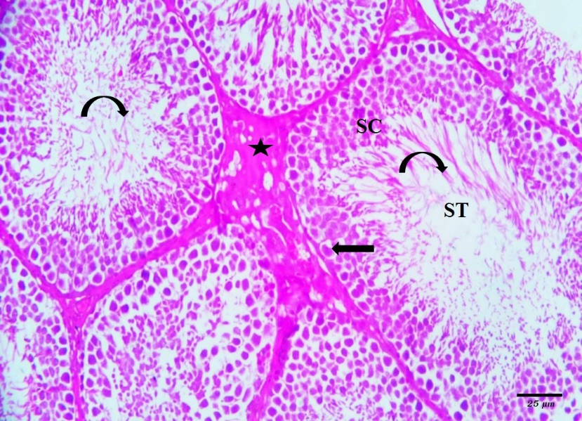
Figure 1: A photomicrograph of control testicular section showing seminiferous tubules (ST) lined by spermatogenic epithelium (SC) and Sertoli cell (arrow), with sperms (curved arrow) in their lumens with leydig cells were seen in minimal interstitial tissue (asteric) between the seminiferous tubules
[H&E, x400].

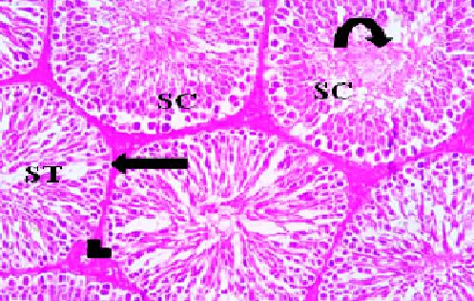
Figure 2 : A photomicrograph of Resveratrol group testicular section showing most probably normal architecture : seminiferous tubules (ST) lined by spermatogenic epithelium (SC) and Sertoli cell (arrow), with sperms (curved arrow) in their lumens. Normal blood vessel (arrow head) embedded through interstitial tissue between the seminiferous tubules [H&E,x 400].

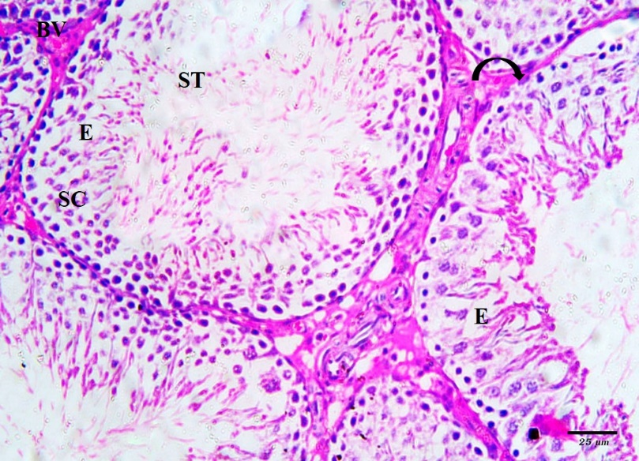
Figure 3: A photomicrograph of Tramadol- treated group of testicular section illustrating distorted seminiferous tubules(ST), Sertoli cell (curved arrow) resting on irregular basement membrane, detached spermatogenic cells (SC), Spermatogenic cells appear with many exfoliate pyknotic or irregular darkly stained nuclei, empty spaces (E) and the interstitial tissue contains congested blood vessels (BV) [H&E, x400].

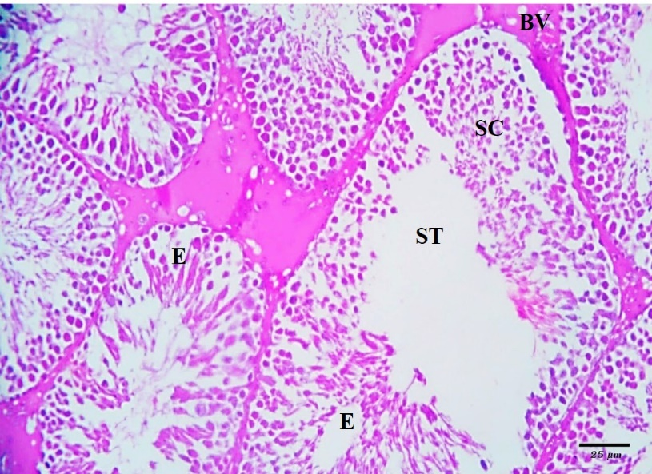
Figure 4: A photomicrograph of Tramadol- treated group of testicular illustrating deformed seminiferous tubules(ST) with detached spermatogenic cells (SC), Spermatogenic cells appear with pyknotic or irregular darkly stained nuclei. Note appearance of empty spaces (E) and the interstitial tissue contains congested blood vessels (BV) [H&E, x400].

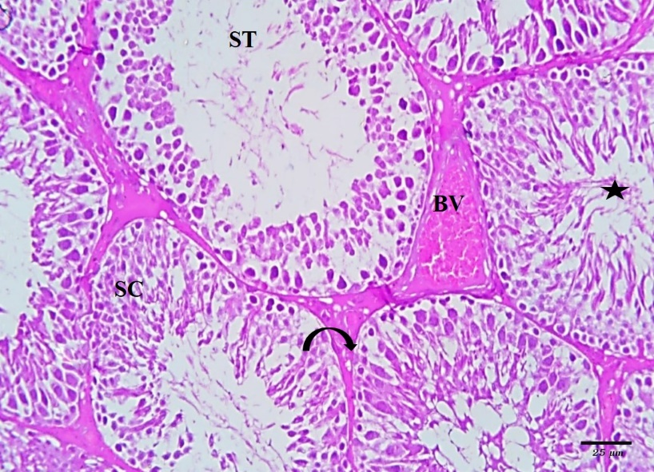
Figure 5 : A photomicrograph of Tramadol & Resveratrol treated group( group IV) of testicular section showing more or less normal seminiferous tubules (ST) lined by spermatogenic epithelium (SC) and Sertoli cell (curved arrow), the lumen filled with sperms (asteric). Note congested blood vessel in the interstitial tissue (BV)
[H&E, x400].

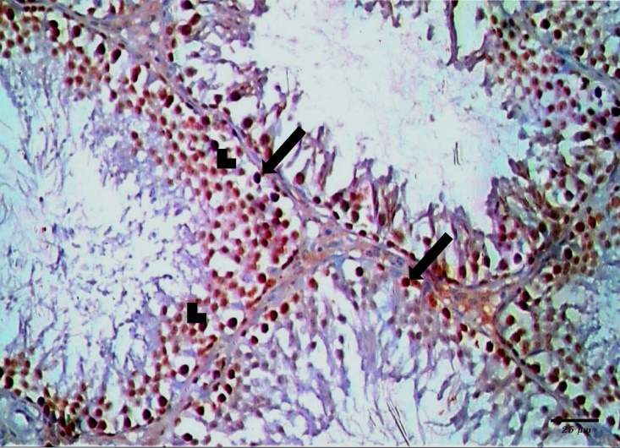
Figure 6: A photomicrograph of PCNA immunostained testicular section of control group showing positive nuclear immunoreaction in spermatogonia (arrow) and primary spermatocytes (arrowhead) [PCNA x400].

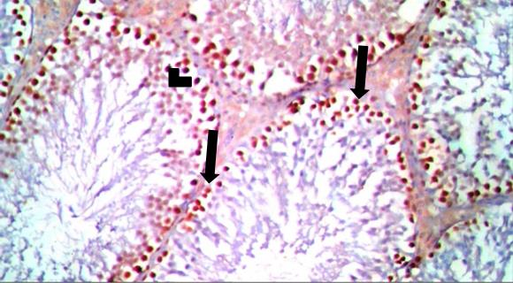
Figure 7 : A photomicrograph of PCNA immunostained testicular sections of Resveratrol group showing positive nuclear immunoreaction in spermatogonia (arrow) and primary spermatocytes (arrowhead) [PCNA x400].

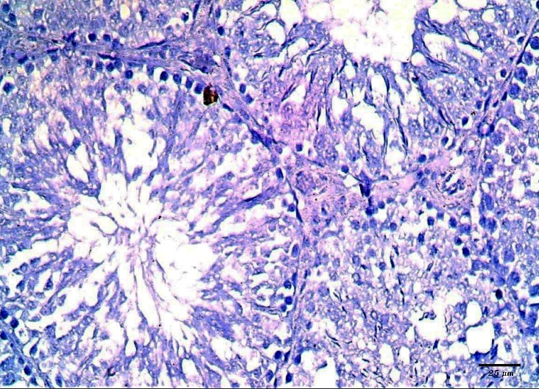
Figure 8 : A photomicrograph of PCNA immunostained testicular section of Tramadol treated group showing negative nuclear immunoreaction in spermatogonia and primary spermatocytes [PCNA x400].

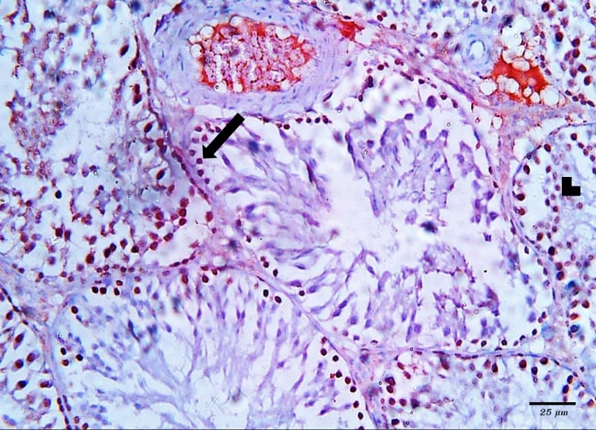
Figure 9 : A photomicrograph of PCNA immunostained testicular section of Tramadol treated group showing few positive spermatogonia (arrow) and primary spermatocytes (arrowhead) [PCNA x400].

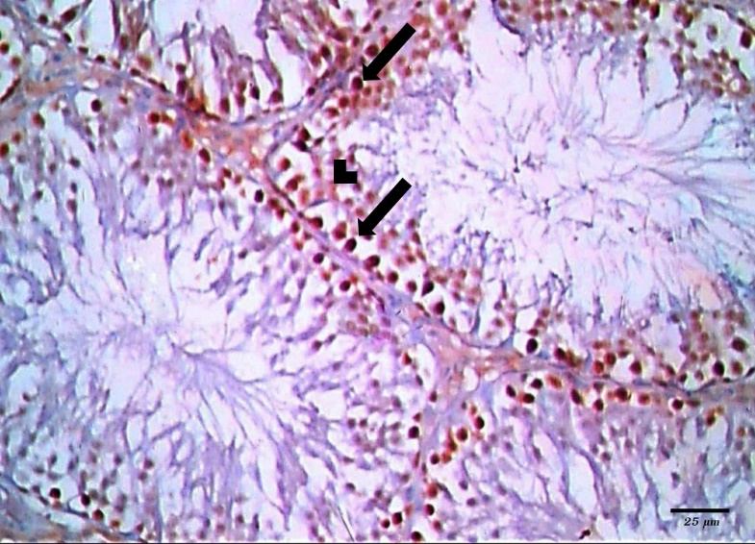
Figure 10 : A photomicrograph of PCNA immunostained testicular section of Resveratrol and tramadol-treated group ( group IV) showing positive nuclear immunoreaction in spermatogonia (arrow) and primary spermatocytes (arrow head) [PCNA x400].

Morphometric results
The mean area % of PCNA immuno-reactivity for all groups was compared. There was insignificant decrease in PCNA immuno-expression (P>0.05) in groups II & IV as compared with control group. The mean area % of PCNA immuno- reactivity was highly significantly increased in control group as compared to group III (P<0.01).The mean area % of PCNA immuno- reactivity was significantly increased in groups II & IV as compared to group III (P≤ 0.05) .Also, area % of PCNA immuno- reactivity was insignificantly decreased in group IV as compared to group II (P>0.05) (Table 1 and Histogram 1).

Table (1): Showing mean values of area % PCNA immune-reactivity ± SD in all groups
Data are expressed as mean ± standard deviation. *P < 0.05 is significant.

P value | F test | Group IV | Group III | Group II | Group I | Mean%  ± SD
0.045 | 4.272 | 13.26± 3.47 | 0.81± 0.16 | 17.76± 2.85 | 19.17± 2.27 | PCNA
 |  | With group III | With groups I, II &IV | With group III | With group III | Significance ≤ 0.05

Histogram (1): Showing mean values of area % PCNA Immunoreactivity in all groups.

Biochemical indices results

Serum LH level was found to be significantly decreased in Tramadol treated animals
compared to the control animals (p<0.05) with significantly higher level in Tramadol-RES treated group compared to Tramadol treated group (p<0.05) .
Serum FSH level was found to be significantly decreased in Tramadol treated animals
compared to the control animals (p<0.05) with a significant increase in Tramadol-RES treated group compared to the Tramadol treated group (p<0.05) .
Serum testosterone level was slightly decreased in the RES group compared to the control group. On the other hand, serum testosterone was significantly lower in Tramadol treated animals compared to the controls (p<0.001) but significantly higher in Tramadol-RES treated group compared to Tramadol treated animals (p<0.001), suggesting that RES treatment relieved testicular toxicity and increased testosterone secretion (Table 2 and Histogram 2).

Table(2) :Showing mean values of FSH,LH & Testosterone± SD in all groups

P value | F test | Group IV | Group III | Group II | Group I | Mean  ± SD
0.001 | 16.128 | 2.2± 0.36 | 0.92± 0.075 | 2.5± 0.3 | 2.76± 0.019 | FSH  (mIU/ml)
0.000 | 25.28 | 2.1± 0.2 | 1.03± 0.316 | 2.33± 0.157 | 2.43± 0.18 | LH  (mIU/ml)
0.000 | 22.31 | 3.4± 0.35 | 1.6± 0.65 | 3.9± 0.36 | 4.12± 0.11 | Testosterone (ng/ml)
 |  | With group III | With groups I, II& IV | With group III | With group III | Significance  ≤ 0.05
Data are expressed as mean ± standard deviation. *P < 0.05 is significant.

Histogram (2): Showing mean values of FSH, LH& Testosterone in the 4 groups

Discussion:
Tramadol is a centrally acting opioid that remains the first choice to relief
pain. Opioids were used as analgesic drugs without considering many side effects. One of these side effects that rarely considered was hypogonadism [20].
In this study the testis of the rats treated with Tramadol showed irregularity of the seminiferous tubules with disorganization and degeneration of spermatogenic cells. The damaged spermatogenic cells were exfoliated in the lumen, which showed absence of sperms. Vacuoles appeared between the degenerated spermatogenic cells, replacing them. There was irregular degenerated basement membrane of seminiferous tubules. Some seminiferous tubules were ruptured. Also; the degree of spermatogenesis was evaluated using PCNA with significant decline in the rats treated with Tramadol.
These findings were in agreement with El Sawy & Abdel Malak , (2015) that Tramadol induced variable degree of degeneration in the seminiferous tubules with vacuolization of spermatogenic layers. Darkly stained nuclei were sloughed into the tubular lumen with decrease in the height of germinal epithelial and in the diameter of seminiferous tubules diameter [21].

It was mentioned in previous study that, the abnormalities in the testicular structures including atrophy of seminiferous tubules with focal testicular degeneration and single or multiple layers of vacuolated spermatocytes that may be referred to the oxidative damaging effect of free radicals. Tramadol produces lipid peroxidation that leading to structural and functional damage of cells [22].

Ahmed & Kurkar , ( 2014 ) reported that Tramadol increased the testicular levels of nitric oxide, lipid peroxidation and decreased the anti-oxidant enzymes activities significantly compared with the control group as well as immunohistochemical examinations showed that Tramadol increased the expression of endothelial nitric oxide syntheses in testicular tissues[8].

In the present study the testis of the rats treated with Tramadol and Resveratrol showed nearly the normal histological profile. Few empty spaces were still seen among spermatogenic epithelium. Interstitial spaces showed blood vessels and polygonal Leydig cells with oval nuclei and acidophilic vacuolated cytoplasm. However, few cells with darkly stained nuclei were observed.

Fikriye, et al., (2017) reported that Resveratrol help in healing testicular damage. The immunohistochemical results within this study were similar to the findings in our study [23].

Similarly, in other investigation it was stated that Resveratrol prevents the lipid peroxidation and DNA damage induced by oxidative stress [24]. Also it was also reported that, Resveratrol improves sperm maturation and lowers the oxidative stress in seminiferous tubules [25].

Apoptosis plays a great role in toxicity. In this study, immunohistochemical staining by PCNA was used to demonstrate the apoptosis. However, RES treatment at daily doses of 20 mg/kg decreased the apoptotic cell count induced by Tramadol. Kasdallah-Grissa ., ( 2006) and Samy, et al., (2014) proved that the protective effects of RES could also be mediated by its promising effect on apoptosis. Resveratrol decreased expression of p53 and Bax genes in healthy and CdCl2-intoxicated rats and improved the mRNA expression of Bcl-2 levels, so this drug may have a protecting effect on testicular tissue [25,26].

Resveratrol has antioxidant potential. So, RES has the ability to reach peroxidized rigid membranes and increase membrane fluidity that helps to interact in a more effective way with radicals. Therefore, the antioxidant activity of RES effect against DNA damage were improved due to Reactive Oxygen Species (ROS) and lipid peroxidation [26,27].

Within another study, it was reported that the impacts of small concentrations of RES were associated with activation of genes that are responsible for oxidative phosphorylation and mitochondrial biogenesis. From which, it was concluded in other study that, RES apart from being an antioxidant, could mobilize the spermatozoa energetic metabolism and therefore improve the viability of spermatozoa [28].

Avdatek et al., (2018) reported that, Resveratrol protects cells against oxidative cytotoxic effects and organizes the action of mitochondrial superoxide dismutase 2 levels that leading to block mitochondrial oxidative stresses [29].

In the present study, significant decrease in the levels of sex hormones (serum LH, FSH and testosterone) in Tramadol treated group in comparison with control group. On the other hand, RES treated group showed that, the levels of these hormones were significantly improved if compared with Tramadol treated group suggesting that RES treatment relieved testicular toxicity and increased testosterone secretion.

These results are in agree with Osadolor&Omo-Erhabor ., (2016) who found that the direct effect of Tramadol on the hypothalamic–pituitary axis leading to reduction in the levels of LH, FSH and testosterone with induction of prolactin and estradiol levels[30]. Also resulted in reduction of testosterone secretion, which could be involved in the involution of the seminiferous epithelium [31].

Both sexual hormones (FSH and LH) are responsible for normal spermatogenesis. The decrease of level of testosterone Consequential followed reduction in peripheral LH, which effect on the height of the seminiferous epithelium. Another explanation for Tramadol to suppress testosterone secretion is to produce nitric oxide (NO) [32]. It can be suggested that destruction of germ cells due to hormonal deficiency. Also the overproduction of nitric oxide and oxidative stress increase by oral administration of Tramadol which affects the testicular function.

Within another study, El-Gaafarawi ., (2006) explained that RES stimulated the gonadotropin secretion which is a major endocrine regulator in spermatogenesis. In that study, serum FSH and LH levels which stimulates spermatogenesis in tubules and testosterone production in Leydig cells were significantly increased in RES treated group in comparison to the control group [33].

Sharma et al., (2014) reported that, RES in testicular toxicity induced by doxorubicin and cypermetrin, there were significant increase in the levels of LH, FSH and testosterone, [34]. These results may suggest that the use of Resveratrol may improve gonadal function after being exposed to testicular toxicity.

Conclusion: This study concluded that Resveratrol ameliorated Tramadol induced testicular damage by reducing oxidative stress and by enhancing level of sex hormones.

Abbreviations
RES: Resveratrol
FSH: Follicle stimulating hormone
LH: Luteinizing hormone
PCNA: Proliferating Cell Nuclear Antigen
ROS: Reactive Oxygen Species
NO: Nitric oxide

Conflict of interest
The authors declare that they have no competing interests.

References:

- Osadolor1, H. B.and Omo-Erhabor, J. A.(2016) : Effects of Tramadol on Fertility Hormones (Follicle Stimulating Hormone, Leutinizing Hormone, Prolactin, Testosterone, Estrogen and β-HCG) in Laboratory Rabbits. British Journal of Medicine & Medical Research. 14(8): 1-11. ISSN: 2231-0614.

- Khan AH and Rasaily D (2013) :Tramadol use in premature ejaculation: daily versus sporadic treatment. Indian J Psychol Med; 35:256–259.

- Barber J. (2011) :Examining the use of tramadol hydrochloride as an antidepressant. ExpClinPsychopharmacol; 19:123–130.

- Lindsay TJ, Rodgers BC, Sava THV and Hettinger K. (2010) :Treating diabetic peripheral neuropathic pain. Am Fam Physician; 82:151–158.

- Bell AL. (2011) : Herpes zoster and postherpetic neuralgia: prevention and management. Am Fam Physician; 83:1432–1437.

- Hafez EM, IssaSYand AbdelRahman SM. (2015) :Parenchymatous toxicity of Tramadol: histopathological and biochemical study. J Alcohol Drug Depend; 3:225.

- Elsawy MM, Abdel Malak HW. (2015) :Effect of Tramadol abuse on testicular tissue of adult albino rats: a light and electron microscopic study. Egypt J Histol;38:356–366

- Ahmed, M.A., Kurkar, A. (2014): Effects of opioid (Tramadol) treatment on
and detection efficiency of the peroxidase antiperoxidase (PAP),
avidin-biotin (LAB) methods. Am.J.Clin.Pathol. Jul;92(1):62-67.

- Baur JA, Sinclair DA. (2006): Therapeutic potential of Resveratrol: the in vivo evidence. Nat Rev Drug Discov.;5:493–506. 11.

- Baur JA, Pearson KJ, Price NL, Jamieson HA, Lerin C, Kalra A, Prabhu VV, Allard JS, Lopez-Lluch G, Lewis K, PistellPJ, Poosala S, Becker KG, (2006):Resveratrol improves health and survival of mice on a high-calorie diet. Nature.;444:337– 42.

11. Delmas D, Lancon A, Colin D, Jannin B and Latruffe N. (2006):Resveratrol as a chemopreventive agent: a promising molecule for fighting cancer. Curr Drug Targets.;7:423–42.

- De la Lastra CA. and Villegas I.( 2007) :Resveratrol as an antioxidant and pro-oxidant agent: mechanisms and clinical implications. BiochemSoc Trans.;35:1156–60.

- Leonard S., Xia C., Jiang B. H. et al., (2003): “Resveratrol scavenges reactive oxygen species and effects radical-induced cellular responses,” Biochemical and Biophysical Research Communications, vol. 309, no. 4, pp. 1017–1026,.

- Brittes J, Lúcio M, Nunes C, Lima JL, Reis S. (2010):Effects of Resveratrol on membrane biophysical properties: relevance for its pharmacological effects. ChemPhys Lipids; 163: 747–754. Cell Apr 17; 69(2):367-374.

- Chang CC, Chang CY, Huang JP, Hung LM. (2012) :Effect of Resveratrol on oxidative and inflammatory stress in liver and spleen of streptozotocin-induced type 1 diabetic rats. Chin J Physiol;55:192-20.

- Das S, Das DK. (2007): Anti-inflammatory responses of Resveratrol. Inflamm Allergy Drug Targets.;6:168–73.

- KeirnanJA(2015): Histological and histochemical methods, theory and practice. 5 ed. : Scion Publishing Limited Press;.

- Jiang Y., Peng T., Y. Luo, M. Li, and Y. Lin, (2008): “Resveratrol reestablishesspermatogenesis after testicular injury in rats caused by 2,5-hexanedione,”Chinese Medical Journal, vol. 121, no. 13, pp. 1204–1209,.

- Das S, Das DK. (2007): Resveratrol a therapeutic promise for cardiovascular diseases. Recent Pat Cardiovasc Drug Discov.;2:133–8.

- Reddy, R.G. (2010): Aung T, Karavitaki N, Wass JAH. Opioid induced hypogonadism. BMJ., 341:605–606.

- El Sawy, M. M. and Abdel Malak H.W. (2015): Effect of tramadol abuse on testicular tissue of adult albino rats: a light and electron microscopic study. The Egyptian Journal of Histology , 38:356-366

- Salah, S., Wagih M., Zaki A., Fathy, W. and Eid, A. (2019): Long-term effects of tramadol on the reproductive function of male albino rats: an experimental biochemical and histopathological study. Middle East Fertility Society Journal, 24:3 pages; 1-6.

- FikriyeYasemin Özatik, Orhan Özatik, SemraYiğitaslan, ÇiğdemÇengelliÜne and KevserErol (2017) : Protective role of Resveratrol on testicular germ cells in mice with testicular toxicity .Turk J Urol; 43(4): 444-50

- Heba Youssef S, and Ziadan Azza H M.(2016) : . Histopathological and Biochemical Effects of Acute & Chronic Tramadol drug Toxicity on Liver, Kidney and Testicular Function in Adult Male Albino Rats.

- Kasdallah-Grissa A, Mornagui B, Aouani E, Hammami M, Gharbi N, Kamoun A, et al.( 2006) : Protective effect of Resveratrol on ethanol-induced lipid peroxidation in rats. Alcohol Alcohol;41:236-9

- Samy M Eleaw, Mahmoud A Alkhateeb, Fahaid H Alhashem, Ismaeel Bin-Jaliah, Hussein F Sakr, Hesham M Elrefaey,etal (2014) : Resveratrol Reverses Cadmium Chloride-Induced Testicular Damage And Subfertility By Downregulating P53 And Bax And Upregulatinggonadotropins And Bcl-2 Gene Expression. Journal Of Reproduction And Development, Vol. 60, No 2.

- Fukui M, Yamabe N and Zhu BT. (2010): Resveratrol attenuates the anticancer efficacy of paclitaxel in human breast cancer cells in vitro and in vivo. Eur J Cancer ; 46: 1882-1891

- Lagouge M, Argmann C, Gerhart-Hines Z, Meziane H, Lerin C, Daussin F, Messadeq N, Milne J, Lambert P, Elliott P, Geny B, Laakso M, Puigserver P and Auwerx J. (2006):Resveratrol improves mitochondrial function and protects against metabolic disease by activating SIRT1 and PGC-1α. Cell; 127: 1109–1122.

- Avdatek,F.,Birdane,Y.O.,Turkmen,R.,Demirel,H.H.(2018) : Ameliorative effect of resveratrol on testicular oxidative stress, spermatological parameters and DNA damage in glyphosate‐based herbicide‐exposed rats.Journal of Andrologia. Volume 50, issue 7.

- Osadolor H. B.andOmo-Erhabor J. A. (2016): Effects of Tramadol on Fertility Hormones (Follicle Stimulating Hormone, Leutinizing Hormone, Prolactin, Testosterone, Estrogen and β-HCG) in Laboratory Rabbits. British Journal of Medicine & Medical Research 14(8): 1-11

- Juan ME, González-Pons E, Munuera T, Ballester J, RodríguezGilJE,andPlanas JM. (2005):Trans-Resveratrol, a natural antioxidant from grapes, increases sperm output. J Nutr;135:757-60.

- Ahmed MA, Kurkar A. (2014): Effects of opioid (tramadol) treatment on testicular functions in adult male rats: The role of nitric oxide and oxidative stress. Clin Exp Pharmacol Physiol; 41:317–323.

- El-Gaafarawi I.I. (2006): Biochemical toxicity induced by Tramadol administration in male rats. Egypt J Hosp Med., 23:353–362.

- Sharma P, Hug AU and Singh R. (2014):Cypermethrin-induced reproductive toxicity in the rat is prevented by Resveratrol. J Hum Reprod Sci;7:99-106.

